**DATA ANALYTICS ASSIGNMENT 1**

P. Baby Vineela

VNITSW

4th B.Tech (CSE)

20NN1A05G7

**BAR CHART**

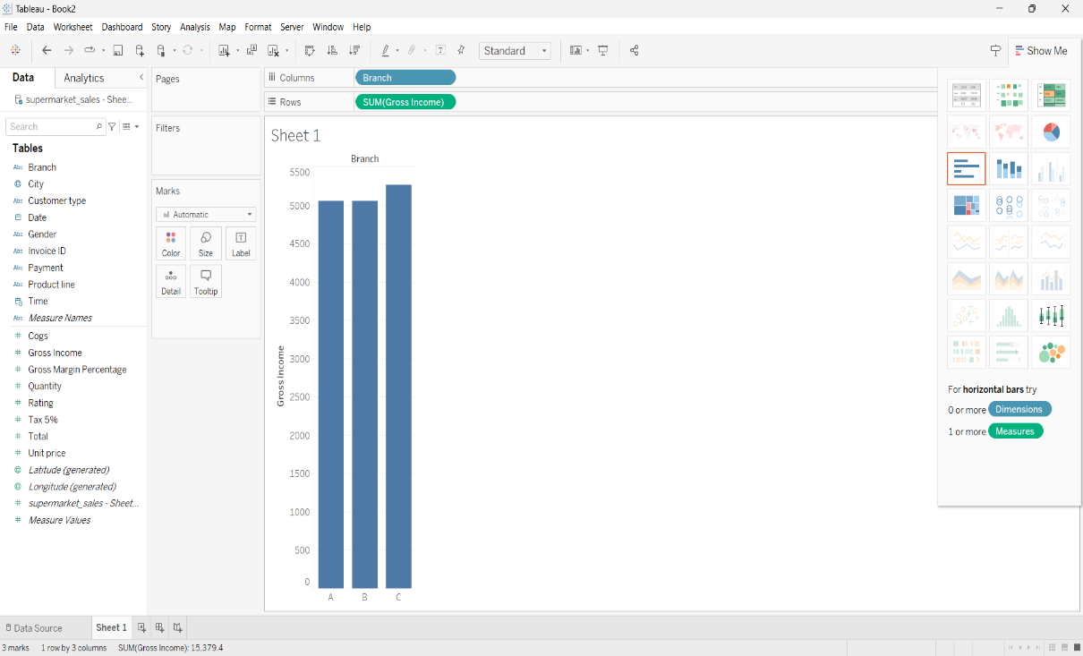

**PIE CHART**

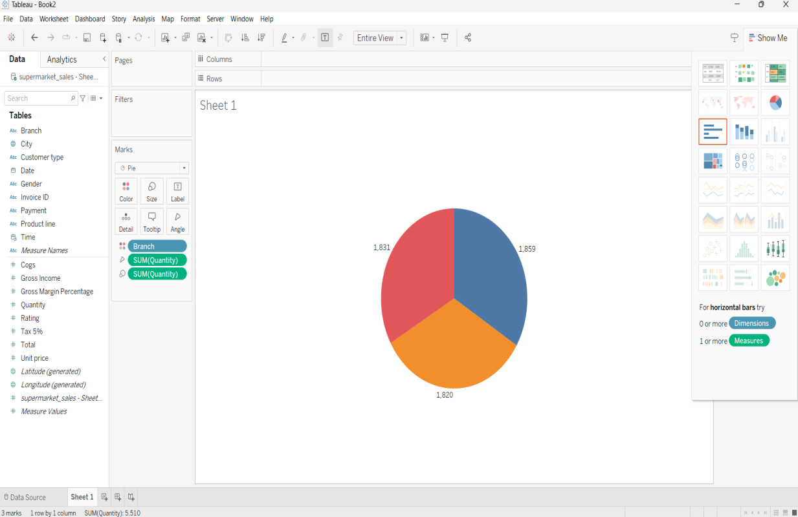

**STACKED BAR CHART**

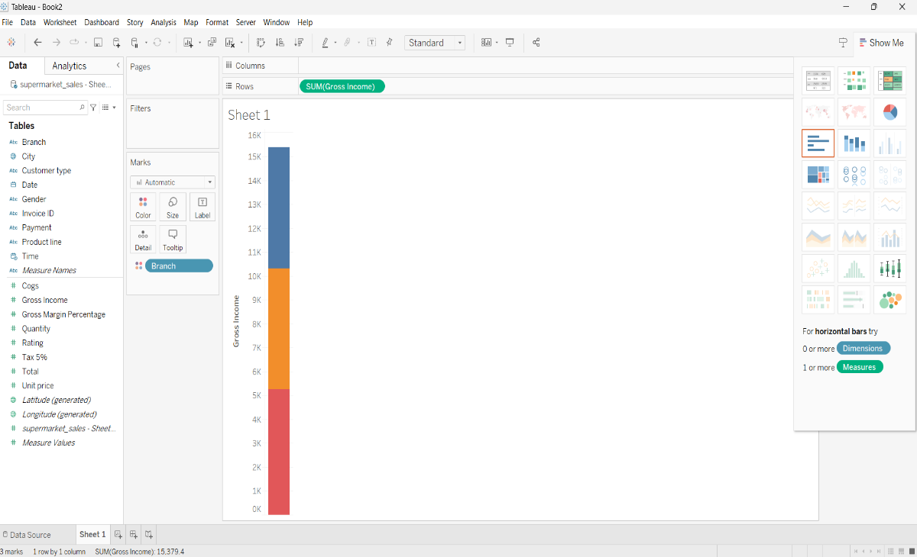

**LINE CHART**

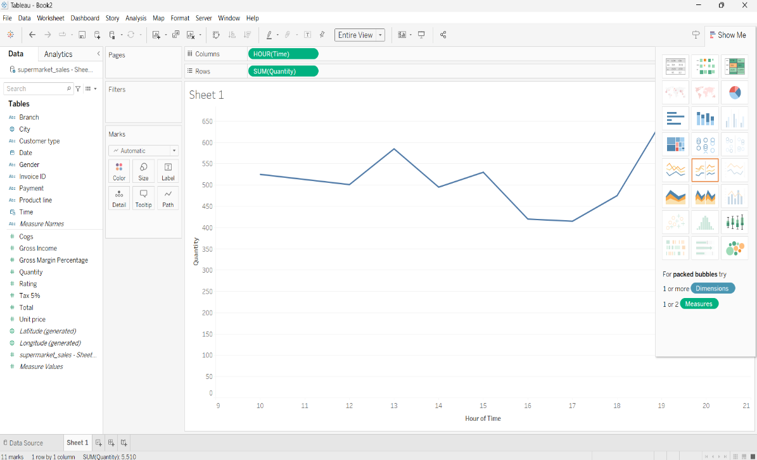

**BUBBLE CHART**

